Developing Soft and Parallel Programming Skills Using

Project - Based Learning

Fall 2018

The Raspberry Pi Bakers

Jordan Aletraris

William Chumley

Riley Greene

Naymish Vaghela

**Tasks:**

|  |  |  |  |  |  |
| --- | --- | --- | --- | --- | --- |
| Name | Email | Task | Duration | Due Date | Notes |
| Jordan Aletraris | jaletraris1@  student.gsu.edu | Creating the video and uploading to Youtube | 30 minutes | 9/14/18 | Completed at the first meeting |
| William  Chumley | wchumley1@  student.gsu.edu | Creating table of group member information, creating the report with input from | 30 minutes | 9/14/18 | Completed at the first meeting |
| Riley Greene | rgreene12@  student.gsu.edu | Creating the GitHub account | 30 minutes | 9/14/18 | Completed at the first meeting |
| Naymish  Vaghela | nvaghela1@  student.gsu.edu | Creating the report with input from the group, submitting the report | 1 hour | 9/14/18 | Created for everyone to add to on google docs |

**Appendix**

Slack Screenshot:

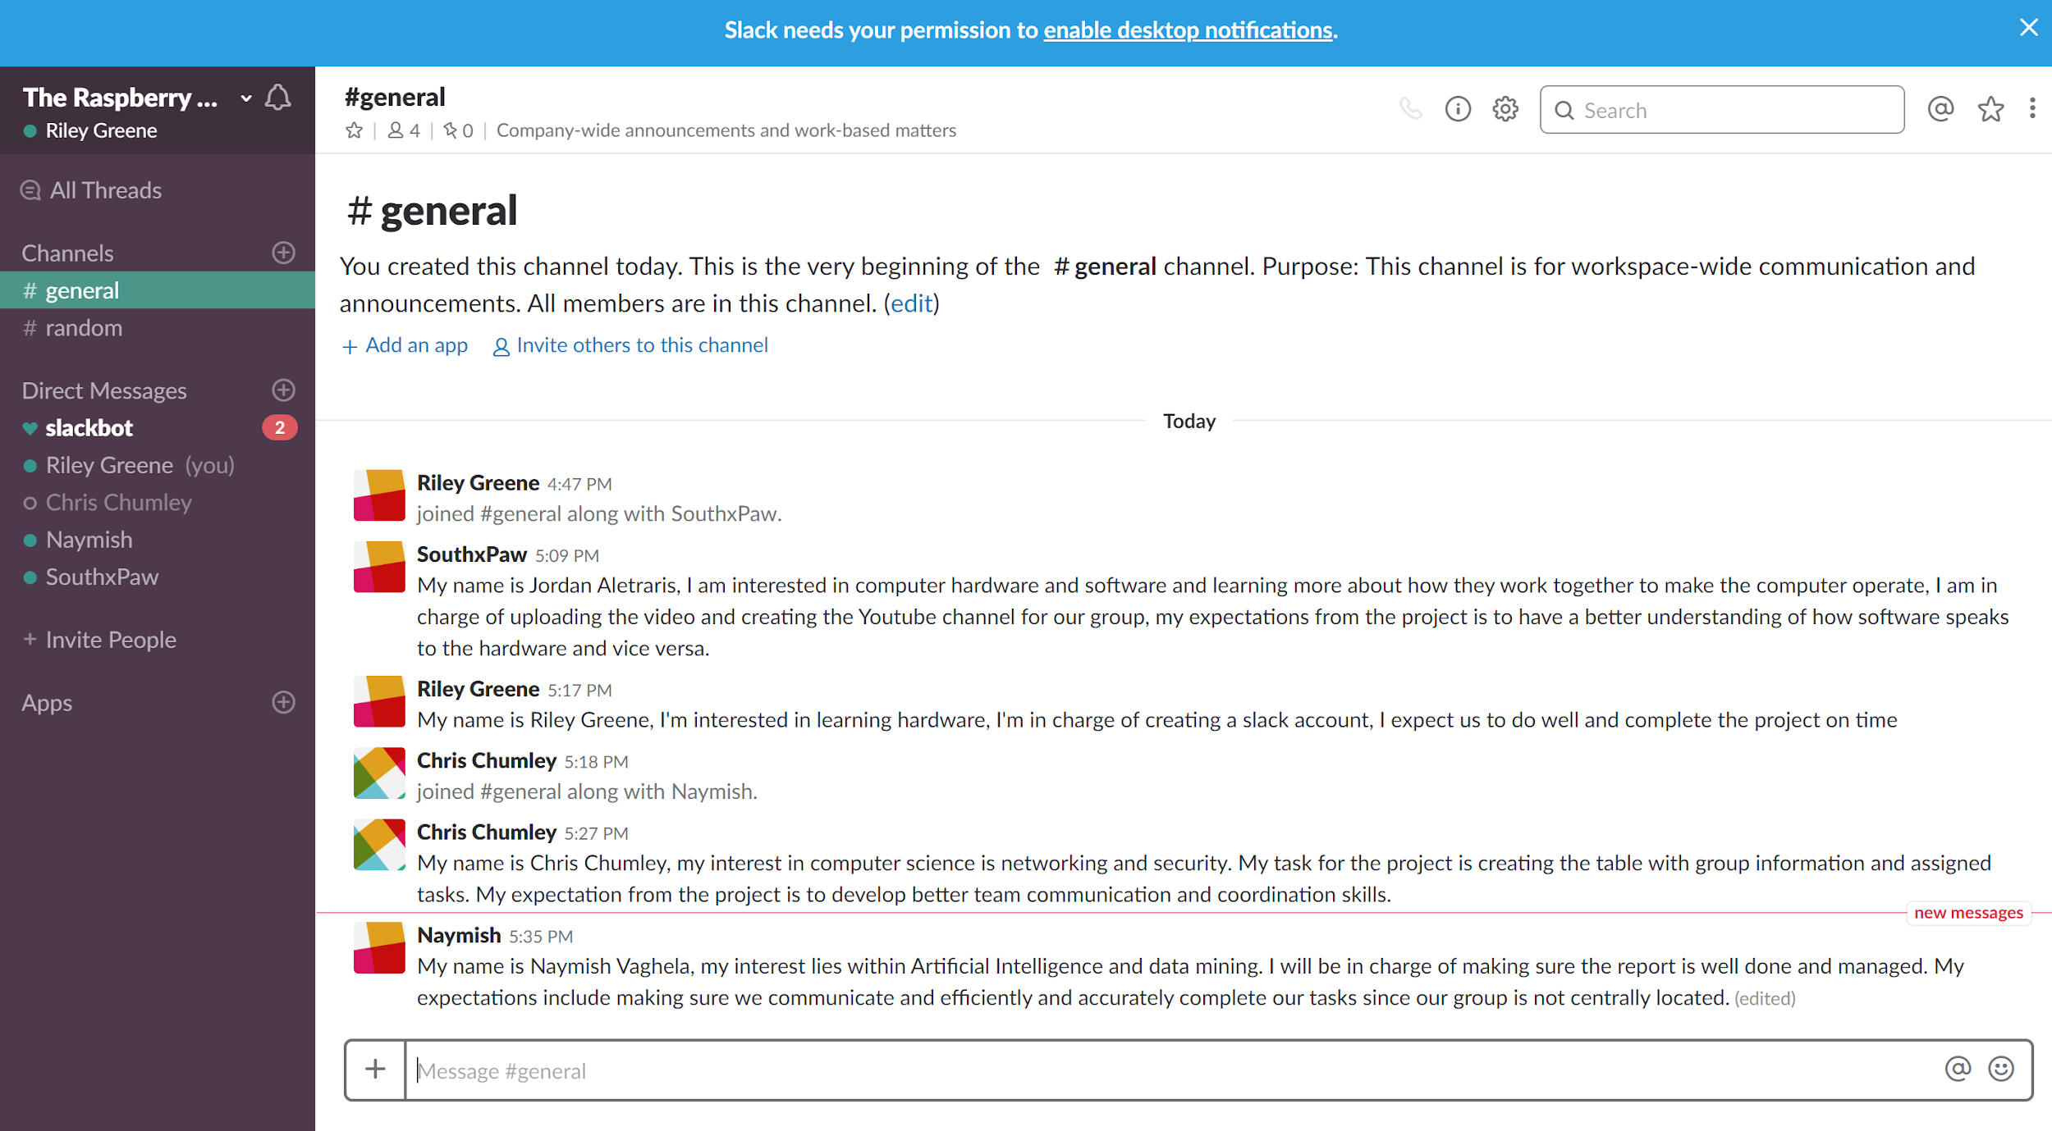

Youtube Video:

<https://youtu.be/J4l_72do5Nc>

Slack group link: <https://theraspberrypibakers.slack.com/messages>